**A Project Report**

**on**

**FIFA World Cup 2022: Argentina Performance Analysis**

**Submitted to:**

**Md Mahbub E Noor**

**Lecturer**

Department of Computer Science and Engineering

University of Barishal

**Submitted by:**

**Nayan Karmaker Deep**

Roll: 12

Batch: **Office_67**



Table of Contents

Executive Summary 1

Introduction 2

Objectives 2

Key Performance Insights 2

Goal Contributions 2

Assist Contribution 3

Defensive Contributions 3

Midfield and Playmaking 4

Winning Moments & Celebrations 5

Conclusion 5

Recommendations for Future Tournaments 6

References 6

**Table of Figures**

Figure 0‑1 Sum of Goal 2

Figure 0‑2 Assist Contributions 3

Figure 0‑3 Defensive & Midfield Overall Contributions 4

Figure 0‑4 Winning Moment Photograph of Argentina 5

# Executive Summary

This report provides an in-depth analysis of Argentina's performance during the 2022 FIFA World Cup. The analysis focuses on key performance indicators such as goals scored, assists, dribbles, tackles, and duels won per 90 minutes. Key players who significantly contributed to the team's success are identified, with a detailed breakdown of their strengths and areas for improvement. The report concludes with a summary of Argentina’s overall performance and recommendations for future strategic improvements.

# Introduction

The FIFA World Cup is the most prestigious international football tournament, bringing together the best players from around the world. Argentina, one of the tournament’s most successful teams, performed exceptionally well in the 2022 edition, ultimately winning the title. This report examines the detailed player statistics available in the dataset to evaluate individual contributions and performance metrics.

# Objectives

* To analyze key performance metrics of Argentina’s players.
* To identify standout performers and their contributions.
* To evaluate Argentina’s defensive and attacking strengths.
* To provide insights into areas for future improvements.

# Key Performance Insights

Argentina's road to glory was marked by resilience, teamwork, and outstanding individual performances. The dataset provides various performance metrics, including dribbles, tackles, and interceptions per 90 minutes.

## Goal Contributions

* Lionel Messi: Scored 7 goals and provided 3 assists.
* Julian Alvarez: Scored 4 goals, proving to be a clinical finisher.
* Alexis Mac Allister: Scored 1 goal and provided a crucial assist in the final.
* Angel Di Maria: Scored in the final, demonstrating his big-game impact.

Figure ‑ Sum of Goal

## Assist Contribution

The dataset records a total of **16 assists**, reflecting the team's collective effort in creating goal-scoring opportunities. **Lionel Messi** led the contributions with **3 assists**, while **Angel Di Maria, Enzo Fernandez, and Nicolas Otamendi** each provided **1 assist**, showcasing a well-balanced playmaking approach. Contributions from both midfielders and defenders highlight the team's dynamic attacking strategy. However, a **"Grand Total"** row in the dataset lists only **8 assists**, indicating a possible data inconsistency that may require further verification. Overall, the assist distribution underscores a **team-oriented style of play**, with Messi playing a key role in facilitating goals. Further analysis could examine the nature of assists, such as open play vs. set-piece contributions, to gain deeper tactical insights.

Figure ‑ Assist Contributions

## Defensive Contributions

Nicolás Otamendi showcased his defensive reliability, averaging 1.3 tackles and 1.17 interceptions per 90 minutes, providing stability at the back. Alongside him, Cristian Romero played a crucial role with his timely clearances and aerial dominance, ensuring Argentina remained solid defensively. However, it was Emiliano Martínez who delivered the most decisive moments, with his heroic performances in penalty shootouts proving instrumental in securing Argentina's victories. Together, these three players formed a formidable defensive core, playing a key role in their team's success.

## Midfield and Playmaking

Alexis Mac Allister and Enzo Fernández were instrumental in midfield, efficiently breaking defensive lines with their precise passing and intelligent movement. Rodrigo De Paul complemented them with his relentless pressing and ability to win back possession, adding balance to Argentina’s play. Meanwhile, both Mac Allister and Papu Gómez showcased effective dribbling skills, excelling in one-on-one duels and helping drive the team forward. Together, this midfield unit combined creativity, work rate, and technical ability, playing a vital role in Argentina’s overall dominance.

Figure ‑ Defensive & Midfield Overall Contributions

## Winning Moments & Celebrations

Argentina's victory in the final against France was one of the most thrilling matches in World Cup history. After a 3-3 draw in extra time, Argentina won the penalty shootout 4-2. Below are some memorable moments:

* Messi lifting the World Cup trophy after leading Argentina to victory.
* Di Maria’s emotional goal celebration in the final.
* Emiliano Martinez’s crucial save in extra time and penalty shootout heroics.
* 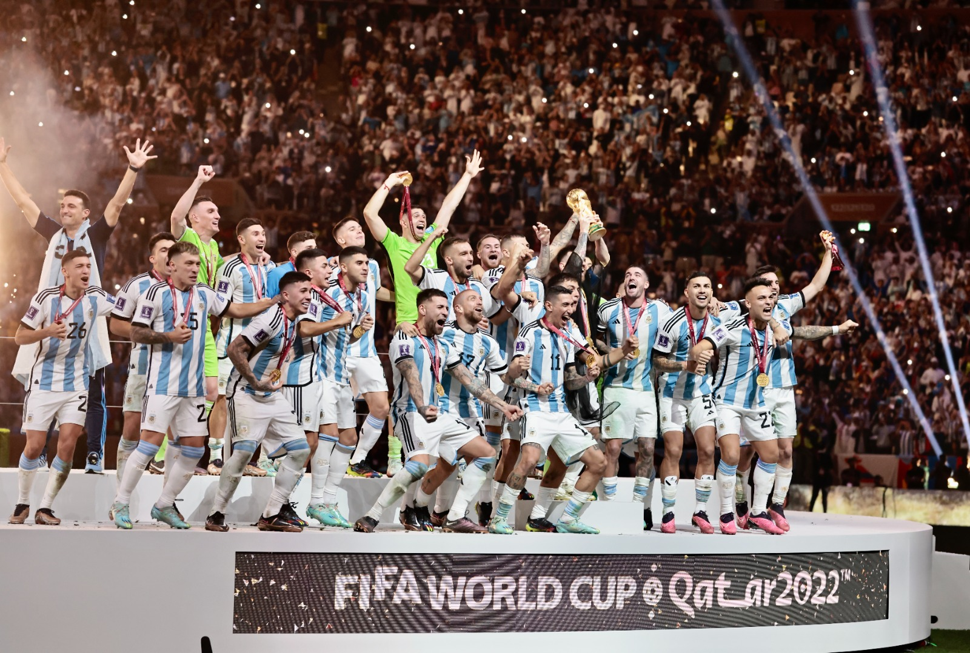Jubilant scenes in Buenos Aires as millions celebrated Argentina’s third World Cup title.

Figure ‑ Winning Moment Photograph of Argentina

# Conclusion

Argentina’s triumph in the 2022 FIFA World Cup was a result of exceptional teamwork, strategic planning, and individual brilliance. Lionel Messi’s leadership, along with contributions from Julian Alvarez, Enzo Fernandez, and others, made the campaign unforgettable. Defensive stability, midfield playmaking, and attacking coordination were key factors in their success.

# Recommendations for Future Tournaments

* Strengthen squad depth to maintain consistency.
* Enhance tactical flexibility to adapt to different playing styles.
* Continue developing young talents like Julian Alvarez and Enzo Fernandez.

# References

* 2022 FIFA World Cup Performance Sample Data (Excel Dataset)
* FIFA Official Website
* ESPN Match Statistics